- General Info
Project | ASSOCIATED ENTERPRISES
Dev Link | https://xd.adobe.com/view/7385897f-4b5e-42da-9653-d14d84f2389e-26d6/
Programmed site | https://www.websentialsdraft3.com/associated-ci/
Fonts & Assets | https://drive.google.com/drive/folders/1S1OqwKmC6zPtTdxDWzhvJLA0Xr3FuvSZ
HitPay Api
HitPay Salt
Section | Draft link error | Supposed outlook | Issue spotted
Slider Banner |  |  | Slider banner image not sliding
Back end categories | 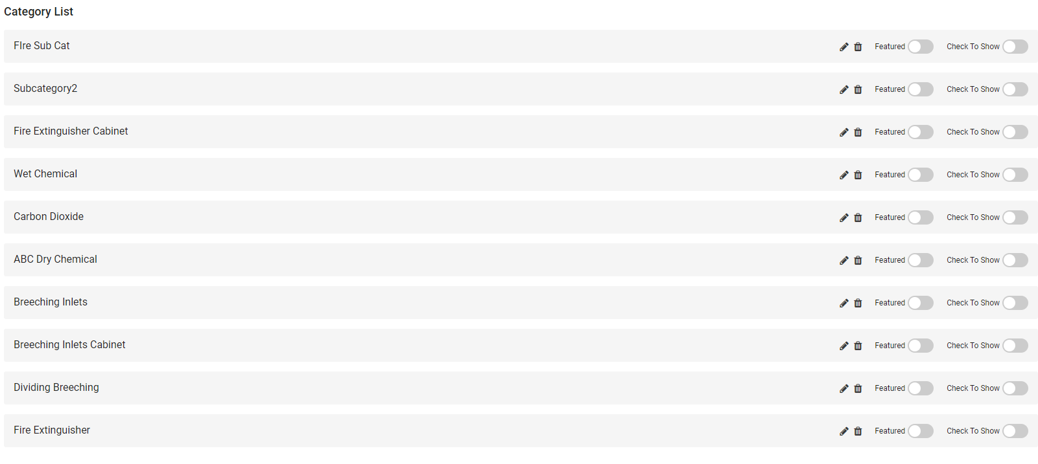 |  | Previously the issue was at the product page where sub catogries are not able to track where they fall under the main categories. Please do the same for the cateogries list as well, the sub categories would show when click upon the main categories. If not if wont appear just like that like a main categories
Article | 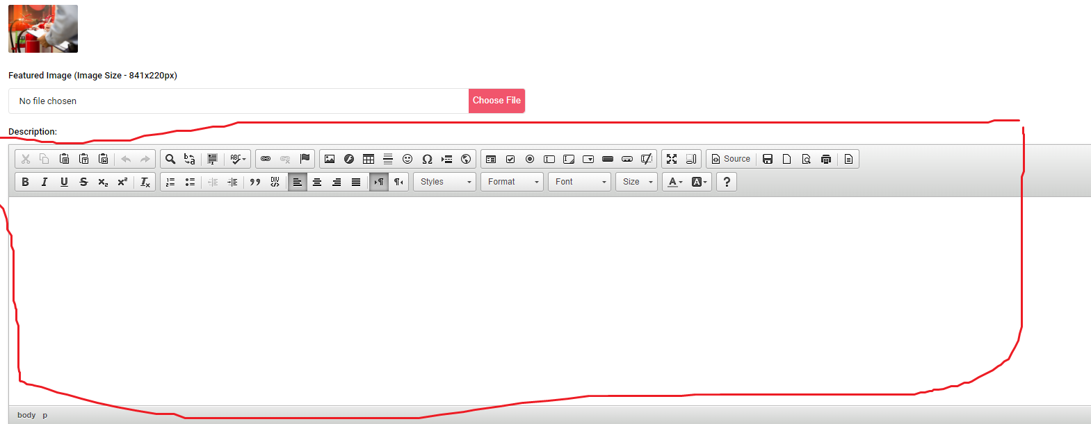 |  | Error at this input field on the back end. This input field is currently not working- not able to type anything, Please fix this as it is not fix during the previous refinement
Backend order list | 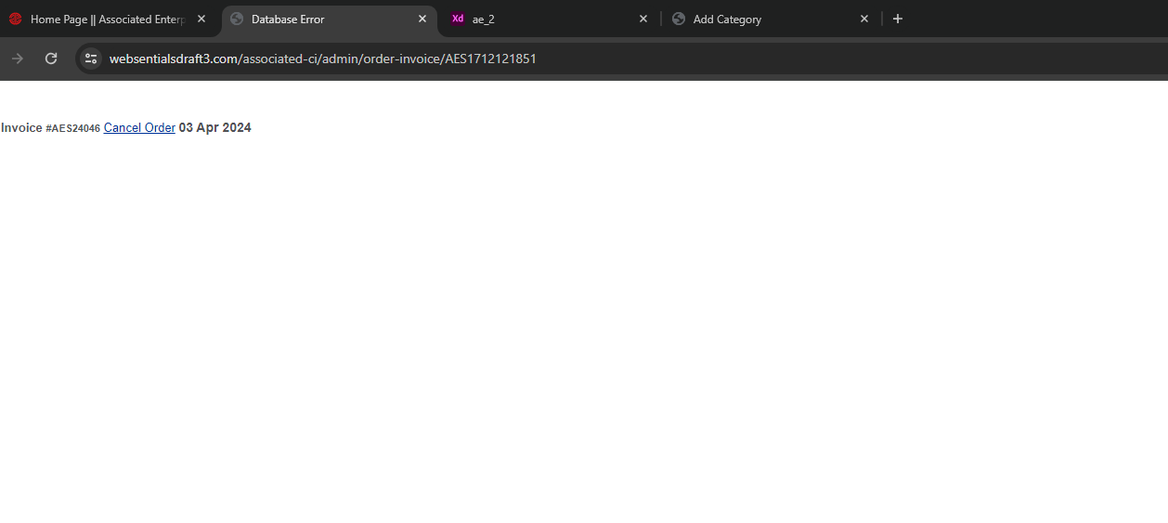  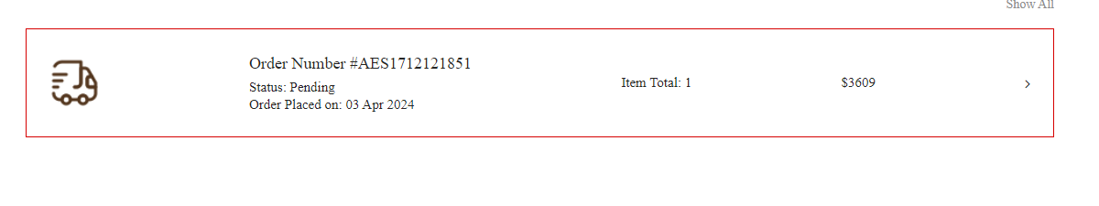 | 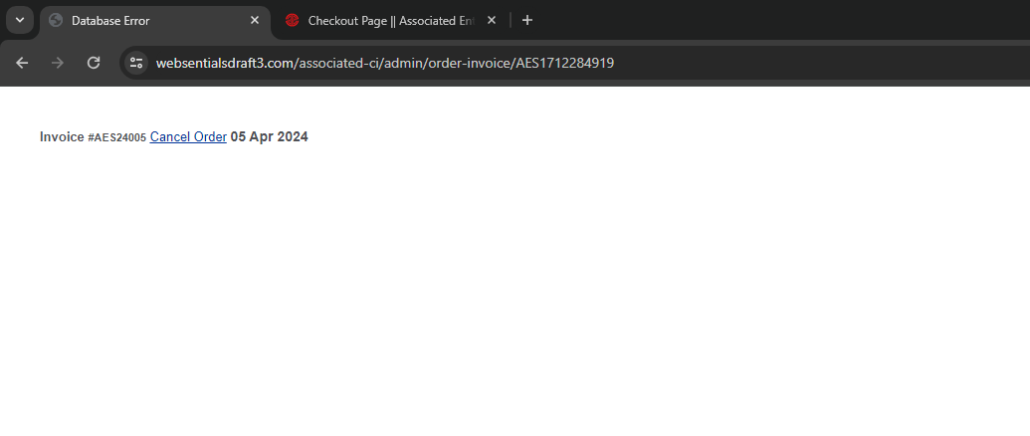 | After user has checkout for a product. Site admin unable to view the order. It shows database error. Please fix this issue ,previous refinement not fix
shop | 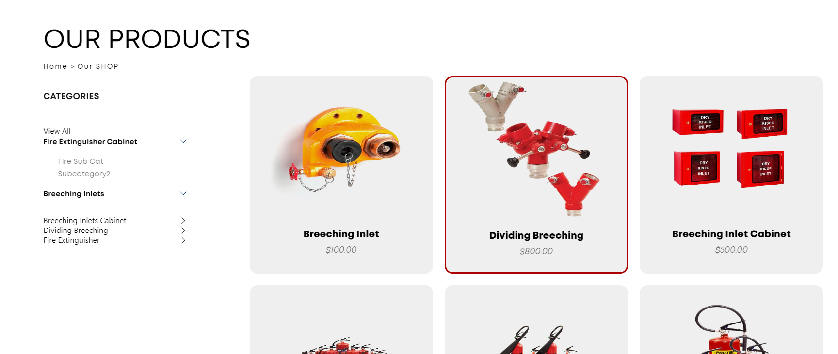 |  | Currently the categories when click upon unable to show the specific products that fall under this category. Please fix this issue

